
Welcome to Gezim Swim Program (GSP).
We are gald to inform you that you are one step closer to improving your swimming skills, and/or learn how to help someone in case of an emergency. Feel free to call us (347) 574-8420 GSPGuard@gmail.com
For all Lifeguard/WSI/LGI bring in an ID with D.O.B on it.

First Name: MI: Last Name: LG only D.O.B:

Address: Apt# Boro/City: State: Zip: .

Cell# ( Telephone #( Emergency#: ( .

How did you hear about the program? E-mail:

Whats is your Reasons/Profesion for taking this course? .
Type of Courses &Prices/Promotional Code
American Heart Association: Instructor Courses: BLS Instrutor for Healthcare Provider $350 Heartsaver Instructor $ 350
Health Care Provider: Basic Life Support (BLS) w/Skills $80 Advanced Cardiovascular Life Support (ACLS) $295
Heartsaver: Adult/Child CPR w/AED $80 First-Aid $80 First Aid w/ CPR/AED $125 Blood-Borne-Pathegens $50
Part # 1 Online Key: BLS $30 CPR/AED $30 First Aid $30 (Please note you have to take part#1 prier to taking skills)
Skills Part # 2 : BLS Skills $ 40 First Aid w/CPR/AED Skills $60 CPR/AED Skills $40 (Note take online Part#1 prier to Skills)

American Red Cross: Lifeguarding $395 Lifeguard Rev. $250 Lifeguard Instructor $ 400 W.S.I Course $ 410
CPR-pro/AED $130 CPR/PRO Rev. $ 110 Respond-to-Emergency w/ Epi $ 195 First Aid $ 75 Admin. Oxy. $ 85

Learn-to-Swim: Groups $ 35 / (30 min) Private $ 60 / (45min) Semi-Private $ 75 / (45 min) Water Aerobics $ 20 Members Pakage “9 (30-min) swim session” $ 275.00 Members Pakage “9 (45-min) swim session” $ 480.00

Other Courses: Fee $ Class date& time: CPR mask $15 *Tell a friend about GSPGuards & earn Discounts*
Date
Time
IMPORTANT: Full payment MUST be received PRIOR or ON the day of the class. Visit us at www.GSPGuard.com for full disclosure in refund policy. Please do not mail any Cash payments. (Please make check/money order payable to Gezim Swim Program.) Remit all Checks/M.O to address listed below.
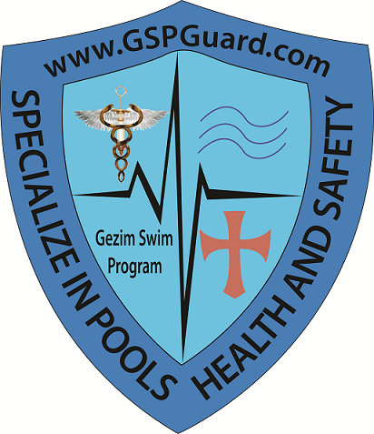
Gezim Swim Program
157 Kings Highway 2nd Floor
Brooklyn NY, 11223

__ ______ __
Student’s Signature Date Print First& Last Name Date

Gezim Cell# (347) 574-8420
Gezim Swim Program (GSP) is not responsible for any participant’s personal belongings. In the event of injury, I agree not to hold GSP or any of its employees responsible for any expenses that may occur. However, I hereby authorize GSP staff to act for me/my child according to their best judgment and ability in any emergency requiring medical attention. I also give permission to use my medical insurance coverage information if deemed appropriate. I understand that there are no refunds, unless GSP cancels the class. I hereby give consent for the student named above to be photographed and all pictures will be used solely for benefit of GSP. I understand that GSP has programs that are physical and therefore involves certain risks. I understand that I/my child will engage in activities such as water play, instruction and swimming. I acknowledge that I/my child are physically able to engage in the moderate to vigorous activities, which the pool involves. I understand that children will be supervised only during class hours and that I am solely responsible for inappropriate behavior in the swimming pool, classroom area or locker room areas, show disregard for GSP staff and facitity rules, become a danger to self or others, ect. I declare that I/my child are in good health and able to participate in the programs that GSP are offering. I will inform the instructor/GSP staff of any special needs that I have. *If you wish to recieve 5% off the total, make www.GSPGuard.com your home page and/or by referring students you know to our classes. The Promotional code is (gspguard home)**
Guardian/ Parent Signature Date Instructor Signature Date
Official Use only:
Date: | Recieved $ | Method: | Location:
Fee $ | Recievable $ | Discounts $ | Operation.

